Assignment Problems: Day 11

The following problems require access to the file named ‘Dataset_Day11.csv’, provided with this assignment. (Use Random State = 99)
This is the same assignment data as Day 10.
The datasets include data from 768 women with several medical predictor variables and one target variable(‘Outcome’). The classification goal is to predict whether or not the patients in the dataset have diabetes or not.
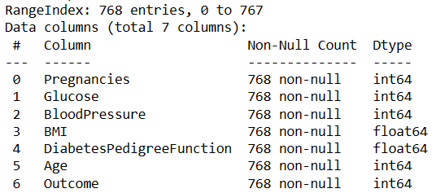
For columns:
Glucose,
BloodPressure,
BMI,
DiabetesPedigreeFunction
If the column value is 0, then they should be considered as missing data.
Problems to solve –
- Firstly, replace all Missing values with relevant figures.
- Then remove all existing outliers and get the final data for classification.
- Split the data into 80% training and 20% testing data. Use target variable as ‘Outcome’.
  - Use Bagging algorithm on Decision trees to classify Outcome and print the default model performance metrics: Accuracy, Precision, Recall, F1Score. Plot F1Score & accuracy against parameter: n_estimators with range of values from 2 to 25.
  - Use Random Forest algorithm to classify Outcome and print the default model performance metrics: Accuracy, Precision, Recall, F1Score. Plot F1Score * Accuracy against parameter: n_estimators with range of values from 2 to 25.
  - Use Adaboost algorithm on Decision trees to classify Outcome and print the default model performance metrics: Accuracy, Precision, Recall, F1Score.

